2005qerMovie Guideqer2005

Monty Python's Flying Circus

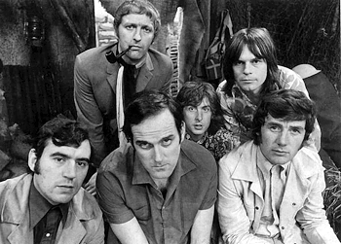

- And Now For Something Completely Different 1971
- Monty Python and The Holy Grail 1974
- Jabberwocky 1977 ( Jones )
- Monty Python's Life Of Brian 1979
- Time Bandits 1981 ( Gilliam )
- Monty Python's Meaning Of Life 1983
- ( + The Crimson Permanent Assurance 1983 )
- Brazil 1985 ( Gilliam )
- Clockwise 1985 ( Cleese ) VHS
- Labyrinth 1986 ( Jones )
- A Fish Called Wanda 1988 ( Cleese, Palin ) VHS
- The Adventures of Baron Munchausen 1988 ( Gilliam )
- Erik The Viking 1989 ( Jones )
- The Fisher King 1991 ( Gilliam )
- The Wind In The Willows 1996 ( Jones ) VHS
- Fear And Loathing in Las Vegas 1998 ( Gilliam )

Mel Brooks



16. The Producers (1968) (writer, director ) VHS
17. The Twelve Chairs (1970) (writer, director, actor) VHS
18.Young Frankenstein (1974) (co-writer, director)
19. Blazing Saddles (1974) (writer, director, actor)
20. Silent Movie (1976) (writer, director, actor) VHS
21. High Anxiety (1978) (writer, director, actor) VHS
22. History of the World, Part I (1981) (writer, director, actor)
23. To Be or Not to Be (1983) (actor)
24. Spaceballs (1987) (writer, director, actor)
25. Life Stinks (1991) (writer, director, actor)
26. Robin Hood: Men in Tights (1993) (writer, director, actor)
27. Dracula: Dead and Loving It (1995) ( writer,director,actor)

DIFFERENTS :

28. Planes, Trains and Automobiles ( J.Hughes )
29. Beetlejuice ( Tim Burton )
30. Howard The Duck 1988 ( G.Lucas )
31. Willow 1988 ( R.Howard/G.Lucas )
32. Enemy Mine
33. Пираты Карибского Моря ( G.Verbinski )
34. Планета Обезьян 1 1968 ( F.J. Sheffner )
35. Clockwork Orange 1971 ( S.Kubrick )
36. Ace Ventura 1,2
37. Mad Max 1,2
38. Men in Black 1 2000 ( B. Sonnenfeld )
40. Blade Runner ( R. Scott )
41. Johnny Mnemonic ( R.Longo )
42. Asterix & Obelix 1,2 ( K.Zidi , A. Shaba )
43. Top Secret ! ( J.Abrahams/Zucker's )
44. Airplane ( J.Abrahams/Zucker's )
45. Hot Shots ! ( J.Abrahams )
46. Зеленая Миля
- Побег из Шоушенка ( F. Darabont )
- Поездка в Америку ( J. Landis )
- В Джазе только девушки ( B.Wilder )
- Властелин Колец 1,2,3
- Shrek 1,2
- Running Man 1987 ( P.M.Glaser )
- All Of Me
- Weekend at Bernie's 1
- The Lawnmower Man 1
- Van Helsing
- Back To The Future 3

Отечественное кино

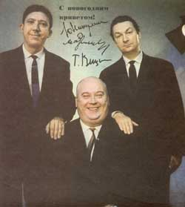

Операция "Ы" и другие приключения Шурика
Бриллиантовая рука
Иван Васильевич меняет профессию
Кавказская пленница
Приключения Ш.Холмса и д.Ватсона :
Король шантажа
Смертельная схватка
Охота на тигра
Сокровища Агры
Красным по белому
Собака Баскервиллей
Руслан и Людмила

MUSIC

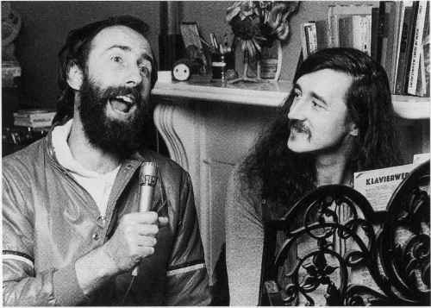

Marc Bolan & T.Rex "Born to Boogie " VCD
Disco Stars ( collection ) VCD
Procol Harum 71 LIVE Radio Bremen
Uriah Heep "Easy living " ( A history )
Shocking Blue " Greatest Hits around the world "
Paul McCartney & Wings 77" Rockshow"
Paul McCartney 2002 " Back in the US "
The Cars 79 " Live on Musiclanden "
Toto 2003 " Live in Amsterdam "
Todd Rundgren 1990"Live in Japan"
I.Q. 1999 " Subterranea-the concert"
Rainbow 77 " Live in Germany "
Rush "Exit-Stage Left" & " A Show Of Hads"
Spandau Ballet
Steely Dan "Aja"
Steely Dan " Two Against Nature"
Ian Gillan Band 77 " Live at Rainbow"
Emerson , lake & Palmer 70
Deep Purple 74"California jam"
Simon and Garfunkel 82 " Concert in Central Park"
Focus Collection footage 71-02
ELO 2000 " Zoom"
David Gilmour 2002 "In Concert"
Glam Rock "The DVD "
Camel "Curriculum Vitae " the story
AIR videos
India Aire " Live in Brazil"
The Temptations ( film )
Jimmy Page & Robert Plant collection
Grand Funk LIVE 1975
The Beatles "Video Collection"
The Beatles "Hard Day's Night"
The Beatles "Help!"
The Beatles"Magical Mystery Tour"
Morcheeba 2002"From Brixton to Beijing"
Jazz on a Summer's Day ( a film by Bert Stern )
B.B.King & Friends 1987
Ella Fitzgerald 1983 with Paul Smith Trio & All Stars
Diane Schuur 1999 And The Count Basie Orchestra
Natalie Cole 2003 " Ask a Woman who Knows "
The Police 84 " Synchronicity Concert" VCD
Utopia 92"Redux"

